**Fermentation Mass Balances**

PFD for this process section

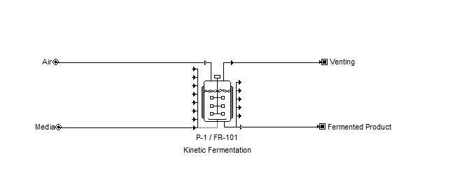

Figure I: Two mass streams enter the system: air and media. Two mass streams exit the system: venting and the fermented product. See the summary tables at the end of this section for stream mass composition.

**Fermenter:**

The pilot plant will have two batch fermenters so that continuous flow can be achieved. Thus, one fermenter will be emptying at a constant rate while the other fermenter is filling and fermenting. For a production rate of 100,000 filled capsules per hour with 1 billion CFU in each pill and assuming a 33 % loss of viable product over the course of separation, drying, and encapsulation the required biomass per hour requirement is as follows.

To attain 93.28 kg biomass/hr with two fermenters, the following system of equation is solved to determine the required batch biomass production

Where is the maximum specific growth rate in h-1.

With a set filling time of 1 hour, a specific growth rate of 1.005 h-1 at 325 K, and an inoculation requirement of 10 %, the batch biomass production is 682.18 kg/batch, fermenting time is 2.29 hours, and emptying time is 3.29 hours.

Standard MRS broth ingredients per liter of solution

|  |  |
| --- | --- |
| **Ingredient** | **Mass** |
| *Proteose Peptone No. 3* | 10.0 g |
| *Beef Extract* | 10.0 g |
| *Yeast Extract* | 5.0 g |
| *Dextrose* | 20.0 g |
| *Polysorbate 80* | 1.0 g |
| *Ammonium Citrate* | 2.0 g |
| *Sodium Acetate* | 5.0 g |
| *Magnesium Sulfate* | 0.1 g |
| *Manganese Sulfate* | 0.05 g |
| *Dipotassium Phosphate* | 2.0 g |

Dextrose is the main carbon source in MRS broth with a concentration of 20 g/L. Assuming 50 % of dextrose is converted to biomass the volume of the broth required and the fermentation vessel can be attained assuming 10 % head space.

Using fresh air with 20 % oxygen, and assuming half of the air is consumed in a molar ration similar to the combustion of dextrose, the required air flow for the fermentation process can be attained.

The venting stream simply replaces the moles of oxygen with moles of carbon dioxide.

*Laboratory Experiments*

To conduct laboratory experiments, proportionally scale down the ingredient requirements shown in the summary tables to determine the recipe based on the desired output of biomass.

Depending on the scale of the experiment, an Erlenmeyer flask can be used to contain the medium and biomass. A scale and multi-sized graduated cylinders will be necessary to mix the medium. Tin foil, autoclave tape, and an autoclave will be necessary to sterilize the flask and medium. A water bath is necessary to cool down the broth prior to inoculation. Finally, a shaking incubator set to 52 deg C will be used for fermentation for a total of 2.29 hours.

**SUMMARY TABLES**

Total time 6.58 hours

Filling time 1.00 hours

Fermentation time 2.29 hours

Emptying time 3.29 hours

Temperature: 325 K

|  |  |  |
| --- | --- | --- |
| **Air Stream IN** | | |
| **Component** | **Mass Flow** | **Component % w/w** |
| *Oxygen* | 2617 kg/hr | 22.00% |
| *Nitrogen* | 9243 kg/hr | 78.00% |
| *Total Flow Rate* | 11860 kg/hr | 100% |

|  |  |  |
| --- | --- | --- |
| **Media Stream IN** | | |
| **Component** | **Mass Flow** | **Component % w/w** |
| *Proteose Peptone No. 3* | 614 kg/hr | 0.95% |
| *Beef Extract* | 614 kg/hr | 0.95% |
| *Yeast Extract* | 307 kg/hr | 0.47% |
| *Dextrose* | 1228 kg/hr | 1.90% |
| *Polysorbate 80* | 61.4 kg/hr | 0.09% |
| *Ammonium Citrate* | 123 kg/hr | 0.19% |
| *Sodium Acetate* | 307 kg/hr | 0.47% |
| *Magnesium Sulfate* | 6.14 kg/hr | 0.01% |
| *Manganese Sulfate* | 3.07 kg/hr | 0.005% |
| *Dipotassium Phosphate* | 123 kg/hr | 0.19% |
| *Water* | 61400 kg/hr | 94.77% |
| *Total Flow Rate* | 64787 kg/hr | 100% |

|  |  |  |
| --- | --- | --- |
| **Venting Stream OUT** | | |
| **Component** | **Mass Flow** | **Component % w/w** |
| *Oxygen* | 1308 kg/hr | 10.59% |
| *Nitrogen* | 9243 kg/hr | 74.84% |
| *Carbon Dioxide* | 1800 kg/hr | 14.57% |
| *Total Flow Rate* | 12351 kg/hr | 100% |

|  |  |  |
| --- | --- | --- |
| **Fermentation Product Stream OUT** | | |
| **Component** | **Mass Flow** | **Component % w/w** |
| *Proteose Peptone No. 3* | 614 kg/hr | 0.95% |
| *Beef Extract* | 614 kg/hr | 0.95% |
| *Yeast Extract* | 307 kg/hr | 0.48% |
| *Dextrose* | 123 kg/hr | 0.19% |
| *Polysorbate 80* | 61.4 kg/hr | 0.10% |
| *Ammonium Citrate* | 123 kg/hr | 0.19% |
| *Sodium Acetate* | 307 kg/hr | 0.48% |
| *Magnesium Sulfate* | 6.14 kg/hr | 0.01% |
| *Manganese Sulfate* | 3.07 kg/hr | 0.005% |
| *Dipotassium Phosphate* | 123 kg/hr | 0.19% |
| *Biomass* | 614 kg/hr | 0.95% |
| *Water* | 61400 kg/hr | 95.50% |
| *Total Flow Rate* | 64297 kg/hr | 100% |

**Fermentation Energy Balance**

Assume the production of heat from fermentation is the only significant energy consideration in the fermentation design. Assume all streams enter and exit at 325 K.

The fermentation heat generation has been found to be 14546 kJ/kg biomass produced. (Türker, 2003)

Using chilled water entering at 5 deg C and leaving at 20 deg C as a cooling medium, the overall water requirement for a batch is shown.

Since the production of biomass is exponential, the flow rate distribution in increments of ten minutes of fermentation time is more description.

|  |  |  |
| --- | --- | --- |
| **Cooling Media** | | |
| **Time** | **Mass Flow** |  |
| 0:00 | 17286 kg/hr |  |
| 0:10 | 20438 kg/hr |  |
| 0:20 | 24165 kg/hr |  |
| 0:30 | 28571 kg/hr |  |
| 0:40 | 33781 kg/hr |  |
| 0:50 | 39941 kg/hr |  |
| 1:00 | 47224 kg/hr |  |
| 1:10 | 55835 kg/hr |  |
| 1:20 | 66016 kg/hr |  |
| 1:30 | 78054 kg/hr |  |
| 1:40 | 92287 kg/hr |  |
| 1:50 | 109115 kg/hr |  |
| 2:00 | 129011 kg/hr |  |
| 2:10 | 149290 kg/hr |  |
| *Total Flow* | 142308 kg/batch |  |

|  |  |  |  |
| --- | --- | --- | --- |
| **Parameter** | **Symbol** | **Units** | **Values** |
| Specific Heat | cp | kJ/kg K | 4.184 |
| Heat of Biomass Production | N/A | kJ/kg | 14546 |

**Centrifugation Mass Balance**

PFD for this process section:

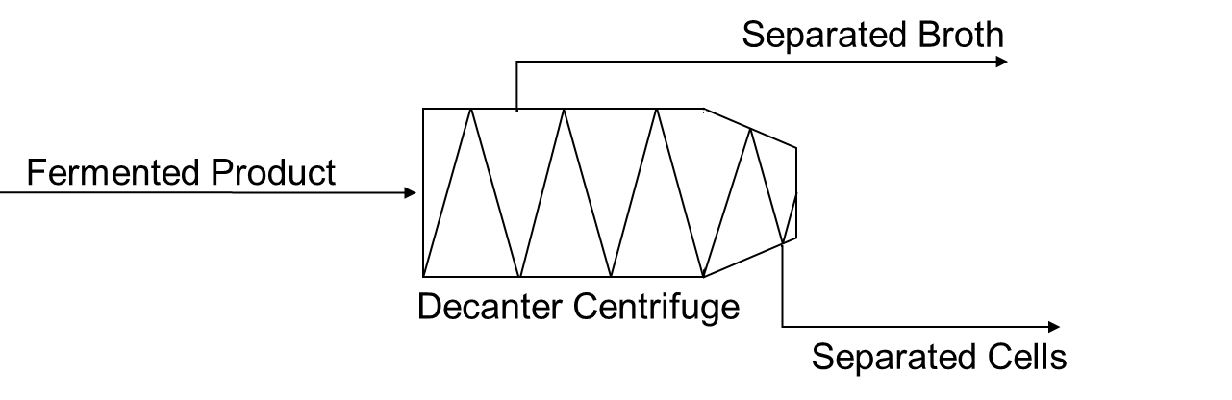

**Centrifuge:**

In the process of centrifugation, the *Bacillus coagulans* formed during the fermentation process will be separated from the rest of the fermentation product media. Continuous or conventional centrifuges are most often used for such cell separation processes (Li, B., *et. al.*, 2016). However, continuous centrifuges are far more preferable for larger scale processes, due to the limitations in capacity for noncontinuous centrifuges (Stanbury, P. F., *et. al.*, 2017; Li, B., *et. al.*, 2016). The process works by continuously feeding in solid-liquid mixture. The aqueous portion of the mixture are continuously expelled, while the solid portions are trapped within the centrifuge. A limitation of this design is that the solid material cannot be collected while the process is running. Assume that the centrifuge also continuously expels the solid material and does not have to be stopped to remove the solids. Additionally, assume that the centrifuge has attained full speed.

The size of *B. coagulans* ranges from 3.0 to 5.0 micrometers, so the centrifuge used for our procedure will be one that has a minimum limiting size of 3.0 micrometers.

The centrifuge for our design has one input stream (the fermented product) and two output streams (the separated fermentation broth and the separated cells). No chemical reactions occur within the centrifuge, so no material is generated or consumed, and thus the total mass of the input stream equals the total combined mass of the output streams.

The composition of the input stream (the fermentation product) was as follows:

|  |  |  |
| --- | --- | --- |
| **Input Stream (Fermentation Product)** | | |
| **Ingredient** | **Mass Flow (kg/h)** | **Mass Fraction** |
| *Ammonium Citrate* | 5.00 | 0.00080 |
| *Beef Extract* | 25.00 | 0.00400 |
| *Biomass (B. coagulans)* | 159.28 | 0.02550 |
| *Dextrose* | 50.00 | 0.00800 |
| *Dipotassium Phosphate* | 5.00 | 0.00080 |
| *Magnesium Sulfate* | 0.25 | 0.00004 |
| *Manganese Sulfate* | 0.13 | 0.00002 |
| *Polysorbate 80* | 2.50 | 0.00040 |
| *Proteose Peptone No. 3* | 25.00 | 0.00400 |
| *Sodium Acetate* | 12.50 | 0.00200 |
| *Water* | 5946.95 | 0.95241 |
| *Yeast Extract* | 12.50 | 0.00200 |

Assuming that the centrifuge has 100% efficiency and that the size of all particles other than the *B. coagulans* are less than 3 micrometers, the output stream should contain only *B. coagulans*, and the waste stream should contain everything else, and there should be no accumulation.

Looking specifically at the mass of the *B. coagulans* (biomass), since that will be used for our probiotic product, the mass of *B. coagulans* that enters in the fermented stream should exit in the Separated Cell stream. (Note, this is under the assumption that the centrifuge is 100% efficient, which is not accurate, but for simplicity of beginning analysis is assumed to be true.) With this knowledge and given that the flow rate of the fermented product stream is 6244.10 kg/h and that biomass makes up 2.55% of that flow, one can solve for the flow rate of biomass in the separated cell stream:

So, the Separated Cell stream should have a flowrate of biomass of 159.2 kg/h.

In the SuperPro data, the flowrate of biomass in the separated cells stream was 159.2 kg/h, as expected. This is because the efficiency of the centrifuge in the program was set to 100%. However, there are other components in this stream, other than biomass. This is likely do to further intricacies taken into account in the program that were simplified out in the above calculations.

For conducting a lab experiment, the same materials and methods as above would be used, including a centrifuge with a limiting size of 3.0 micrometers. The difference would be that the amounts of materials would be scaled down and a bench top centrifuge would likely be used.

|  |  |  |
| --- | --- | --- |
| **Dried Cell Mass Stream IN** | | |
| **Component** | **Mass Flow (kg/h)** | **Component %** |
| *Ammonium Citrate* | 5.00 | 0.080 |
| *Beef Extract* | 25.00 | 0.400 |
| *Biomass (B. coagulans)* | 159.28 | 2.550 |
| *Dextrose* | 50.00 | 0.800 |
| *Dipotassium Phosphate* | 5.00 | 0.080 |
| *Magnesium Sulfate* | 0.25 | 0.004 |
| *Manganese Sulfate* | 0.13 | 0.002 |
| *Polysorbate 80* | 2.50 | 0.040 |
| *Proteose Peptone No. 3* | 25.00 | 0.400 |
| *Sodium Acetate* | 12.50 | 0.200 |
| *Water* | 5946.95 | 95.241 |
| *Yeast Extract* | 12.50 | 0.200 |
| Total Flow Rate | 6244.102 kg/hr | 100% |
|  |  |  |

|  |  |  |
| --- | --- | --- |
| **Separated Fermentation Stream OUT** | | |
| **Component** | **Mass Flow (kg/h)** | **Component %** |
| *Ammonium Citrate* | 5.00 | 0.082 |
| *Beef Extract* | 25.00 | 0.411 |
| *Dextrose* | 50.00 | 0.822 |
| *Dipotassium Phosphate* | 5.00 | 0.082 |
| *Magnesium Sulfate* | 0.25 | 0.004 |
| *Manganese Sulfate* | 0.13 | 0.002 |
| *Polysorbate 80* | 2.50 | 0.041 |
| *Proteose Peptone No. 3* | 25.00 | 0.411 |
| *Sodium Acetate* | 12.50 | 0.205 |
| *Water* | 5946.95 | 97.734 |
| *Yeast Extract* | 12.50 | 0.205 |
| Total Flow Rate | 6084.83 kg/hr | 100% |

|  |  |  |
| --- | --- | --- |
| **Separated Cell Stream OUT** | | |
| **Component** | **Mass Flow (kg/h)** | **Component %** |
| *Biomass (B. coagulans)* | 159.28 | 100 |
| Total Flow Rate | 159.28 kg/hr | 100% |
|  |  |  |

**Centrifugation Energy Balance**

PFD for this process section:



Area of energy consumption:

1. Centrifuge

From the SuperPro data:

Fermentation Product stream: 253.184 kWh/h

Separated Fermentation Broth stream: 188.237 kWh/h

Separated Cells stream: 70.434 kWh/h

Ein = 253.184 kWh/h

Eout = 258.671 kWh/h

Therefore, the centrifuge inputted 258.671 - 253.184 = 5.487kWh/h of energy into the materials as they passed through the centrifuge.

|  |  |  |
| --- | --- | --- |
| **Energy Data** | | |
| **Energy Component** | **Energy kWh/h** |
| *Energy In (fermentation product)* | 253.184 |
| *Energy Out (fermentation broth)* | 188.237 |
| *Energy Out (cells)* | 70.434 |
| *Energy from Centrifuge* | 5.487 |

**Heat Exchanger and Spray Drier Mass and Energy Balance**

PFD for this process section:

**Fan**

The fan is blowing “dry” air into the heat exchanger and then into the spray drier. There is no true mass balance for the fan as the air is being drawn and then outputted at a certain velocity.

9.17

Where E is the energy required by the fan (W), ΔP is the pressure difference (Pa), V is the volumetric flow rate of air (m3/s), and η is the efficiency of the fan.

The mass flow rate of the air was decided to be 10000 kg/hr. The density if air is approximately 1.225 kg/m3 which results in a volumetric flow rate of 22.7 m3/s. The output is expected to be 2000 Pa higher than the initial and the efficiency of the pump is around 0.7. The energy consumption for the fan comes out to be 6.48E4 W.

**Heat Exchanger**

The heat exchanger has no mixing so there is no true mass balance either. This process is based on the heat transfer between steam and air and is assumed to be adiabatic.

Where E is the energy required by the heat exchanger (W), G is the mass flow rate of the gas (kg/s), and ΔH is the specific enthalpy change over the temperature range (kj/kg).

The heating of the air before drying keeps a constant absolute humidity and changes dry bulb temperature.

The overall energy needed to be transferred from the steam is 4.91E3 W, given from the above equation and the assumed processing variables. The total amount of steam needed is based on the heat exchanger design, which is yet to be decided on (a finned tube is shown in PFD).

|  |  |  |
| --- | --- | --- |
|  | **Air in** | **Air Out** |
| **Dry Bulb Temperature** | 25C | 90C |
| **Relative Humidity** | 24% | 10% |
| **Absolute Humidity** | 0.046 kgW/ kgDA | 0.046 kgW/ kgDA |
| **Specific Enthalpy** | 36.9 kj/ kgDA | 213.8 kj/ kgDA |

**Spray Drier**

The spray operates under the principles of a mass balance. Hot dry air and undried material enter. The air then draws water out of the product due to a difference in water activities (relative humidities). All the water lost by the product is assumed to be picked up by the air.

The product stream is assumed to be water and cells after separation. The feed rate for dry cells per hour is 20 kg/hr. The product comes from the separation stage at an assumed 40g water/ g solids and is supposed to be dried down to 5 gW/gS. The final moisture content is assumed to translate to a water activity of 0.1. Moisture isotherms are needed to truly predict this relationship, but this value should suffice for preliminary calculations. The dry air is introduced at an absolute humidity of 0.046 kg water per kg dry air.

|  |  |  |
| --- | --- | --- |
|  | **Value** | **Determined** |
| **Ls (dry feed rate)** | 20 kg/hr | Production Rate |
| **X1 (initial moisture content)** | 40 gW/gS | Separation stage |
| **X2 (final moisture content)** | 5 gW/ gS | Decided |
| **G (dray air feed rate)** | 10000 kg/hr | Assumed |
| **H1 (initial absolute humidity)** | 0.046 kgW/ kgDA | Given |
| **H2 (final absolute humidity)** | 0.05 kgW/ kgDA | Solved (Mass Balance) |

|  |  |  |
| --- | --- | --- |
|  | **Air in** | **Air Out** |
| **Dry Bulb Temperature** | 90C | 78.5C |
| **Relative Humidity** | 10% | 17% |
| **Absolute Humidity** | 0.046 kgW/ kgDA | 0.05 kgW/ kgDA |
| **Specific Enthalpy** | 213.8 kj/ kgDA | 213.8 kj/ kgDA |
| **Wet Bulb Temperature** | 45C | 45C |

In the drier, the air cools while evaporating the water from the product. The change follows the wet bulb temperature line and lowers in temperature but rising in absolute humidity.

**Other Aspects**

Currently, the assumed drying rate is assumed to be at 36 kg/h*m2 and constant. The shape of a cell is a spherocylinder with length of 1 um and diameter of 1 um.

The number of cells is determined from the dry feed rate and the assumed mass of a cell (1E-12 g/cell). The surface area of cell was determined to be 6.28 um2. The time to dry the product is 0.56 s. Hopefully, this will limit the degradation of the cells due thermal death. Energy not yet quantified comes from the atomizer in the spray drier and the steam flow (or gas consumption) in the heat exchanger. There is also potential for the recycling of used air, which would reduce the energy cost of heating the air but could increase drying time.

**Mixer and Capsule Filler Machine Mass Balance**

PFD for this process section:

Mixer

Capsule Filler

Powder Flow Pump

Empty Capsules

Formulation

Dried Cells

Filled Capsules

Formulation

Excipients

**Capsule Filler:**

Our defined hourly rate of production will be 100,000 filled capsules per hour. It is nice to think of these discretely rather than as a bulk-flow. We can achieve conventional bulk-flow analysis, however, when we know the exact mass of formulation inside each capsule. The team has defined that to be 1 gram. Thus,

For the capsule filler, we have 100 kg/hr of formulation flowing into the capsule filler per hour. One can see very quickly that there will be a required 100,000 empty capsules per hour to flow to the capsule filling machine as well. Lets look at the mixer.

**Mixer:**

The mixer has two streams in and one stream out. In this unit operation, we are mixing the dried cell mass together with the excipients. In the formulation, 20% of the mass is due to the dried cells, and the other 80% comes from the excipients. The excipients are comprised of the following ingredients:

* Maltodextrin
* Inulin
* Talc
* Magnesium Stearate
* Colorants (Titanium Dioxide and Iron Oxide).

Per one capsule that contains 1 gram of formulation, the following recipe applies:

|  |  |  |
| --- | --- | --- |
| **Ingredient** | **Mass** | **Mass Fraction** |
| *Bacteria Blend* | 200 mg | 0.2 |
| *Maltodextrin* | 400 mg | 0.4 |
| *Inulin* | 200 mg | 0.2 |
| *Talc* | 50 mg | 0.05 |
| *Magnesium Stearate* | 50 mg | 0.05 |
| *Colorant* | 100 mg | 0.1 |

Note the following mass fractions in the formulation out-stream above.

We can use this to get the mass flowrates of the inlet streams:

We know then by doing a total mass balance around all mass in the mixer system, that the excipient stream must equate to 80 kg/hr of mass flow. We can readjust the mass fractions and calculate the composition of the excipient stream:

|  |  |  |
| --- | --- | --- |
| **Ingredient** | **Mass** | **Mass Fraction** |
| *Maltodextrin* | 400 mg | 0.5 |
| *Inulin* | 200 mg | 0.25 |
| *Talc* | 50 mg | 0.0625 |
| *Magnesium Stearate* | 50 mg | 0.0625 |
| *Colorant* | 100 mg | 0.125 |

We can then multiply the total mass flow rate by the mass fraction to achieve the component mass flow rate inside that stream:

Similar calculations can be made and the following data on all streams entering and leaving the mixer can be summarized into the following tables:

**SUMMARY TABLES**

|  |  |  |
| --- | --- | --- |
| **Dried Cell Mass Stream IN** | | |
| **Component** | **Mass Flow** | **Component %** |
| *Dried Cells* | 20 kg/hr | 100 |
| *Total Flow Rate* | 20 kg/hr | 100% |

|  |  |  |
| --- | --- | --- |
| **Excipient Stream IN** | | |
| **Component** | **Mass Flow** | **Component %** |
| *Maltodextrin* | 40 kg/hr | 50% |
| *Inulin* | 20 kg/hr | 25% |
| *Talc* | 5 kg/hr | 6.25% |
| *Magnesium Stearate* | 5 kg/hr | 6.25% |
| *Colorant* | 10 kg/hr | 12.5% |
| *Total Flow Rate* | 80 kg/hr | 100% |

|  |  |  |
| --- | --- | --- |
| **Formulation Stream OUT** | | |
| **Component** | **Mass Flow** | **Component %** |
| *Dried Cells* | 20 kg/hr | 20% |
| *Maltodextrin* | 40 kg/hr | 40% |
| *Inulin* | 20 kg/hr | 20% |
| *Talc* | 5 kg/hr | 5% |
| *Magnesium Stearate* | 5 kg/hr | 5% |
| *Colorant* | 10 kg/hr | 10% |
| *Total Flow Rate* | 100 kg/hr | 100% |

**Mixer and Capsule Filler Machine Energy Balance**

Scope: Mixer and Capsule Filler Machine

I identified three main areas of energy consumption:

1. The mixer (paddles/screws)
2. The powder flow pump/manifold
3. Capsule machine

**The Mixer:**

I found a study that related many paramteres related to the powder flow and mixer to the power requirmnet of the mixer (Gijón-Arreortúa & Tecante, 2015)

The parameters were as follows:

|  |  |  |  |
| --- | --- | --- | --- |
| **Parameter** | **Symbol** | **Units** | **Values** |
| Bulk Density | ρb | Kg/m3 | 100 |
| Friction Coefficient | µi | Unitless | 0.20 |
| Impeller Volume | VI | m3 | 10 |
| Impeller Length | LI | m | 5 |
| Rotational Speed | N | rpm | 30 |
| Power | P | Watts | ? |
| Friction factor | f | Unitless | 0.71 |
| Gravitational Speed | g | m/s2 | 9.81 |

The power required for a helical impeller mixer can be calculated with the following equation:

**Powder Flow Pump/Manifold:**

Finding equations to calculate the power requirements for powder flow is posing to be extremely difficult. To give a rough estimate, I will simply model the powder as a highly viscous liquid:

|  |  |  |  |
| --- | --- | --- | --- |
| **Parameter** | **Symbol** | **Units** | **Our Values** |
| Power | P | Watts | ? |
| Flow Rate | Q | m3/s |  |
| Efficiency | η | unitless | 0.85 |
| Pressure Drop | ΔP | Pa | 101,300 |

To calculate the flow rate, we can use our mass balance calculations:

Thus,

Our powder flow manifold requires about one order of magnitude greater power than our mixer.

**SuperPro**

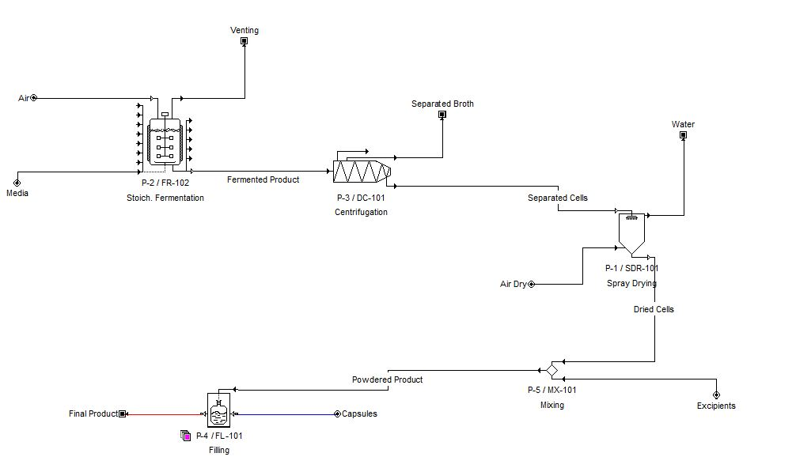

**Stream Composition**

Air

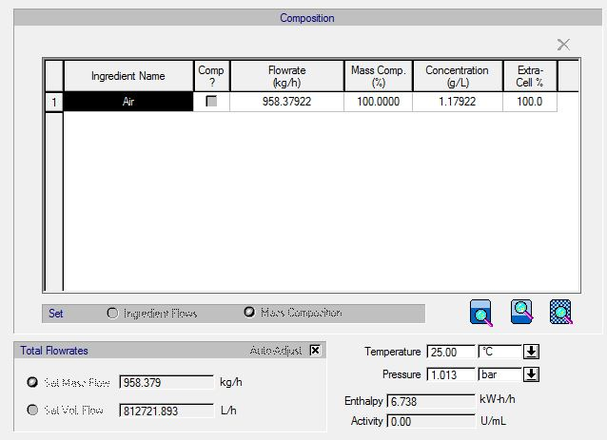

Air Dry

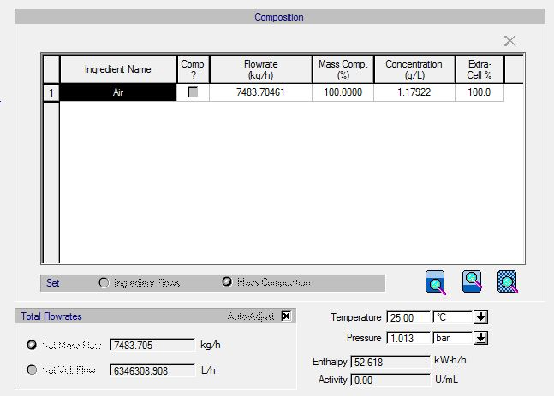

Capsules

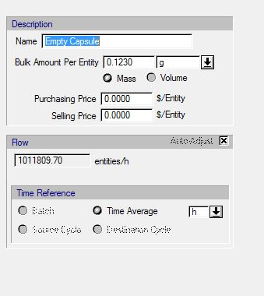

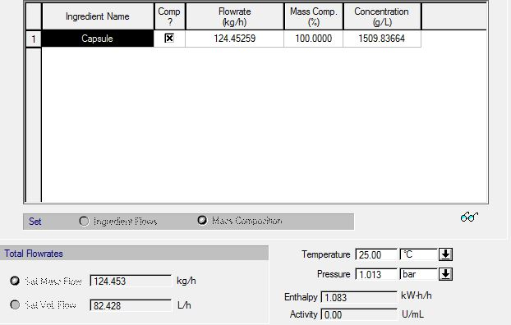

Dried Cells

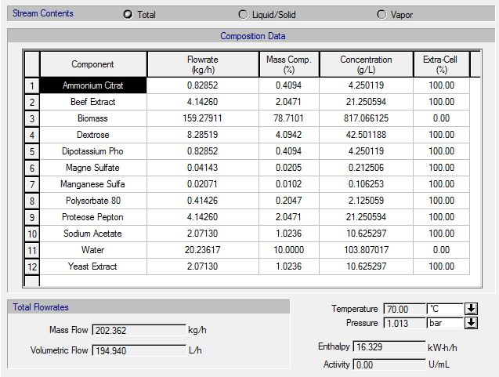

Excipients

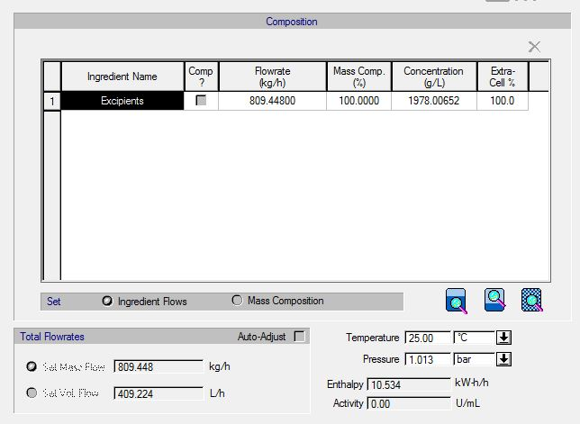

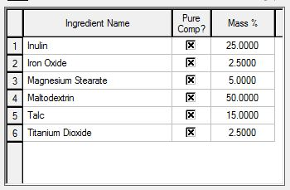

Fermented Product

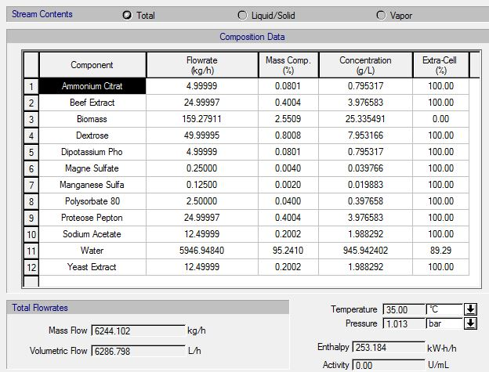

Final Product

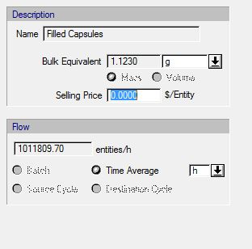

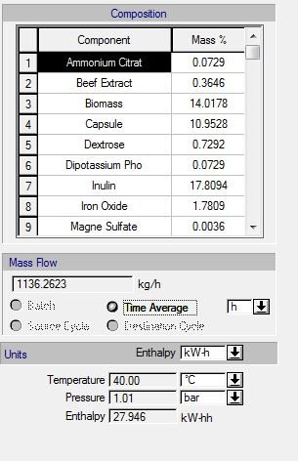

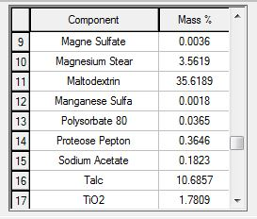

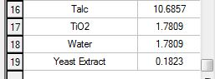

Media

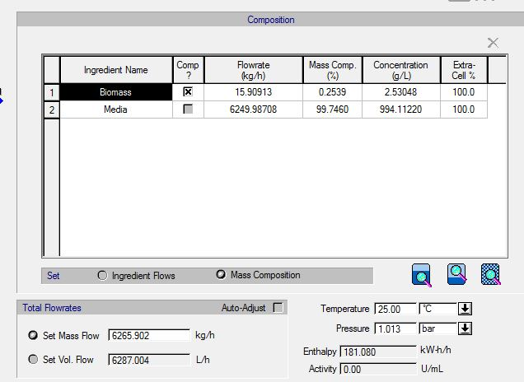

Powdered Product

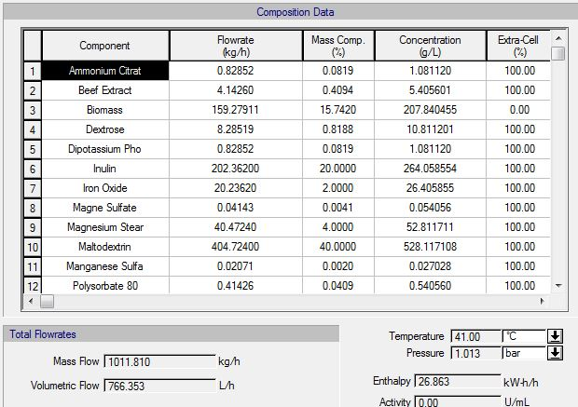

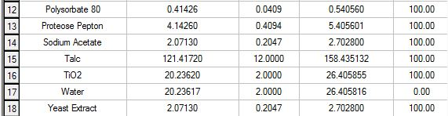

Separated Broth

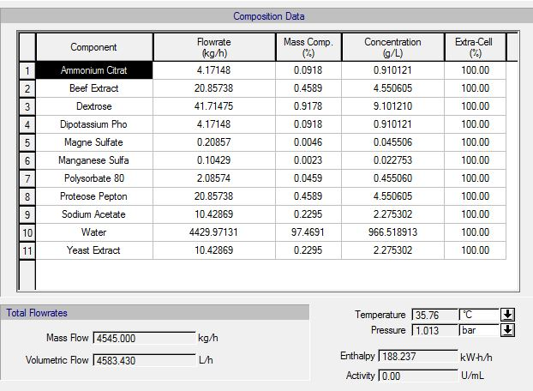

Separated Cells

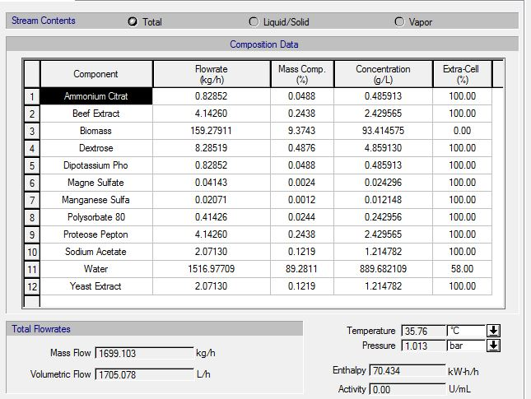

Venting

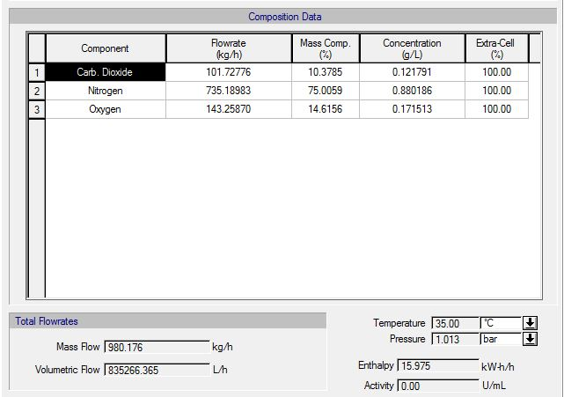

Water

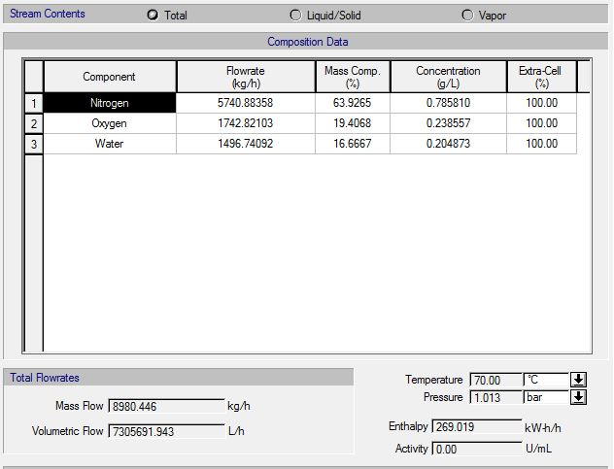

**SuperPro Engery**

Fermenter

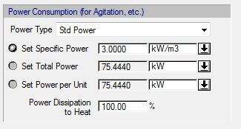

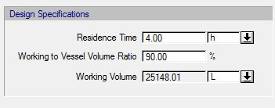

Centrifugation

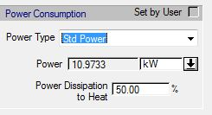

Spray Drying

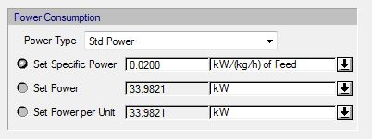

Mixing

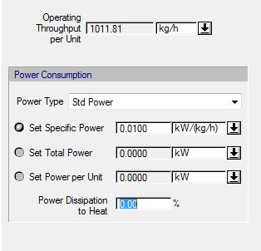

Filling

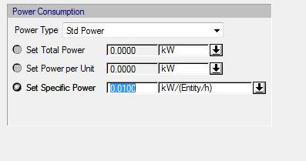

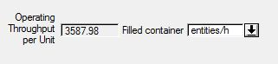

**SuperPro Gantt Chart**

No Gantt chart is generated for continuous production. The process was created as a continuous flow process.

**References**

Gijón-Arreortúa, I., & Tecante, A. (2015). Mixing time and power consumption during blending of cohesive food powders with a horizontal helical double-ribbon impeller. *Journal of Food Engineering*, *149*, 144–152. <https://doi.org/10.1016/j.jfoodeng.2014.10.013>

Li, B., Agular, M., Sun, S., Seeligmueller, N., & Sha, M. (2016, May). Separation of E. coli Fermentation Broths Using the CEPA LE and the Eppendorf® Centrifuge 5920 R Laboratory Systems [Application Note]. CT, USA, Enfield.

Mujumdar, A. (Ed.). (2015). Handbook of Industrial Drying. Boca Raton: CRC Press.

Stanbury, P. F., Whitaker, A., & Hall, S. J. (2017). Principles of fermentation technology. Oxford, U.K.: Elsevier Butterworth-Heinemann.

Türker, M. (2003). Measurement of metabolic heat in a production-scale bioreactor by continuous and dynamic calorimetry. *Chemical Engineering Communications*, *190*(5-8), 573-598.  
<https://www.tandfonline.com/doi/abs/10.1080/00986440302130>